**Creation of Item using Interface Approach**

**Step 1:** Create Staging table:

create table ITEM_STAGING_TBL_1

(segment1 varchar2(40),

description varchar2(150),

template_name varchar2(40),

organization_code varchar2(3),

process_flag char(1),

error_message varchar2(2000),

creation_date date,

created_by number,

last_update_date date,

last_updated_by number);

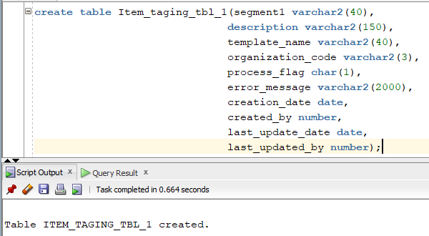

**Step 2:** Create Control file.

options(SKIP=0)

LOAD DATA

infile *

TRUNCATE

INTO TABLE ITEM_STAGING_TBL_1

FIELDS TERMINATED BY ','

OPTIONALLY ENCLOSED BY '"'

TRAILING NULLCOLS (segment1,

description ,

template_name ,

organization_code ,

process_flag "nvl(:process_flag, 'N')" ,

error_message ,

creation_date SYSDATE,

created_by "fnd_global.user_id",

last_update_date SYSDATE ,

last_updated_by "fnd_global.user_id")

**Step 3:** Create a flat file for inserting data into staging table.

|  |  |  |  |  |
| --- | --- | --- | --- | --- |
| 121110 | Keyboard | CUSTOMER PARTS | SLP | N |
| 121111 | Mouse | CUSTOMER PARTS | SLP | N |
| 121112 | Monitor | CUSTOMER PARTS | SLP | N |
| 121113 | Mother Board | CUSTOMER PARTS | SLP | N |

**Step 4:** Place the control file and flat file(data file) in any location.

Here my location is: /u01/12.2.5/edev1/fs2/EBSapps/appl/custom1/12.0.0/bin/

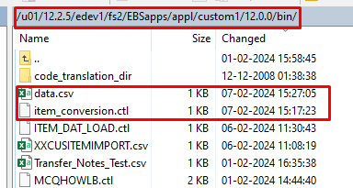

**Step 5:** Create a Concurrent Program to Load the Data from CSV file to Staging table.

➢ **Create Executable**

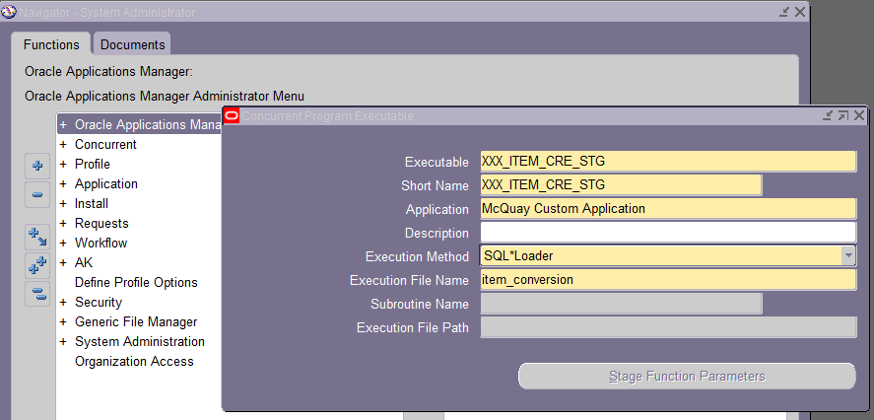

Here **Execution file name is control file name.**

**➢ Create Concurrent Program for that executable.**

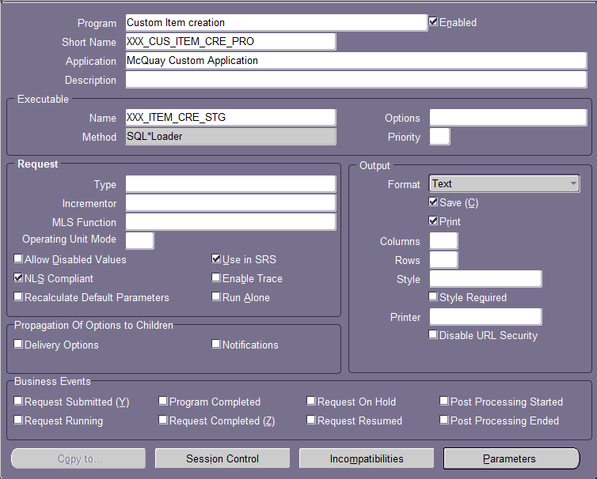

**Parameters**

Path: /u01/12.2.5/edev1/fs2/EBSapps/appl/custom1/12.0.0/bin/data.csv

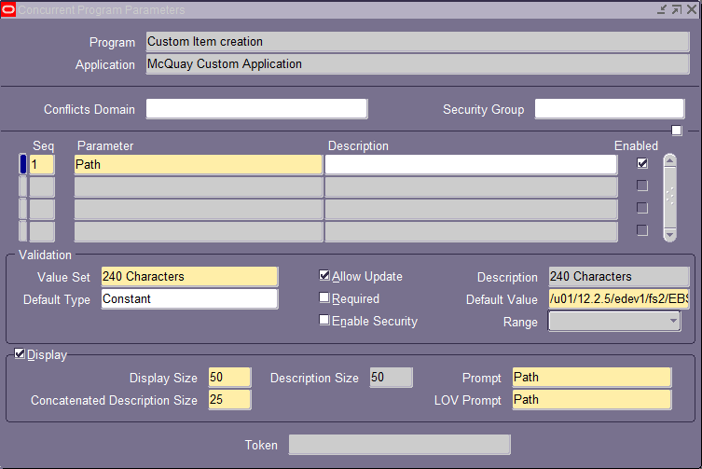

**➢ Request Group**

**Navigation→ System Administrator→ Security → Define**

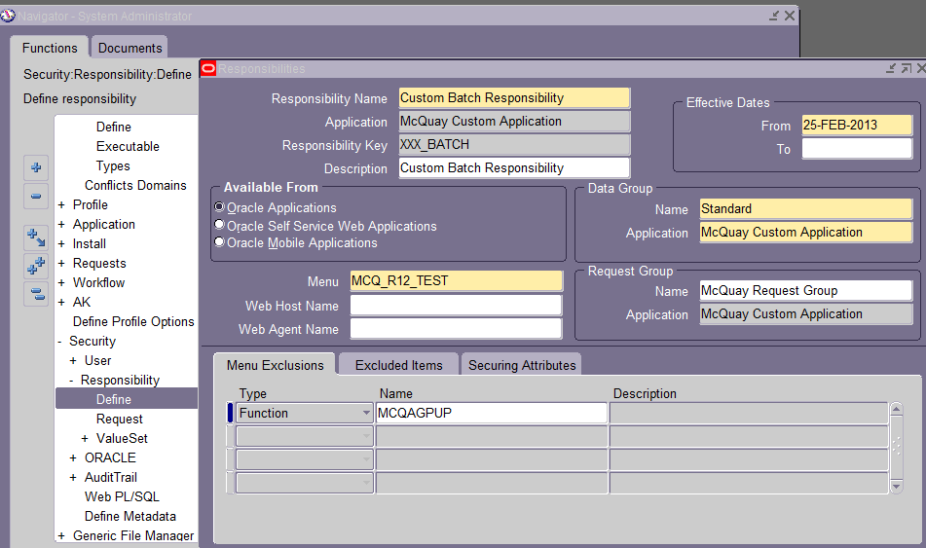

**Navigation→ System Administrator→ Security → Request**

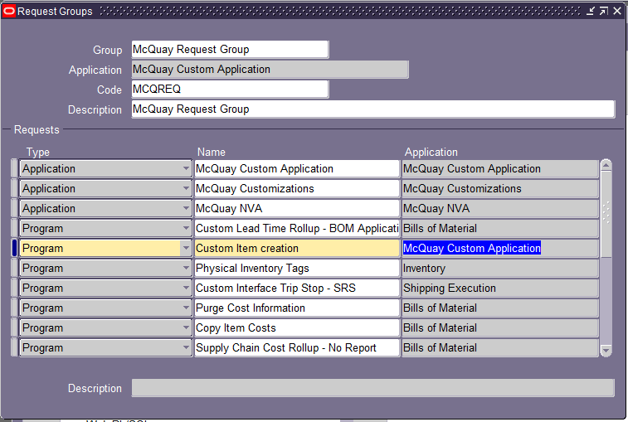

**Step 6:** Run the concurrent program

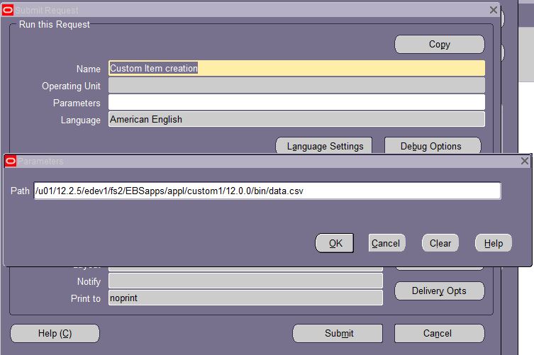

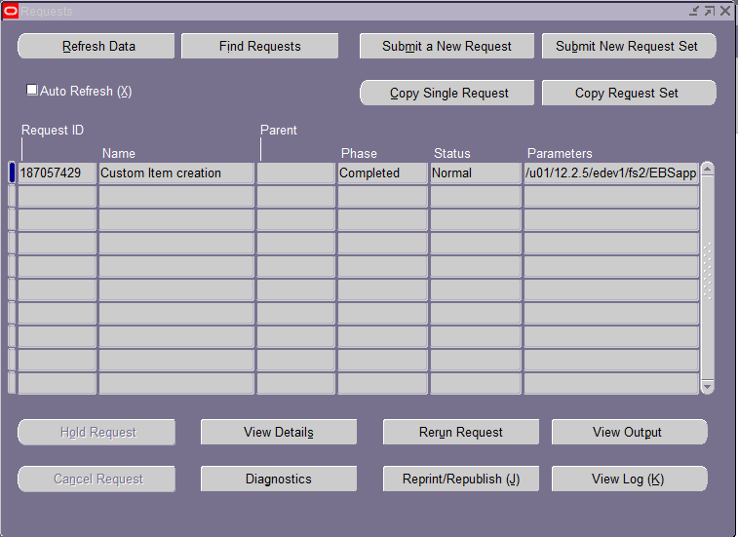

After completing the program, check the staging table whether the records are inserted or not.

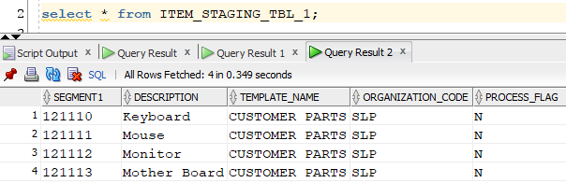

**Step 7:** Create a Package with All required Validations.

The data will import from Stagging table to Interface table and Also Interface table to base table.

**Package:**



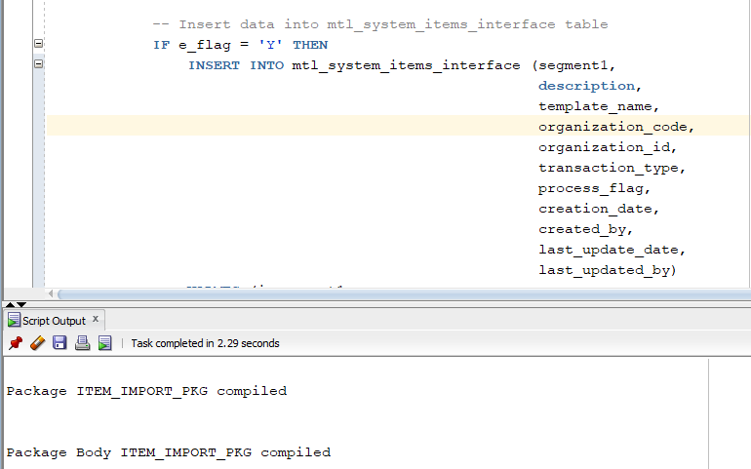

**Step 8:** Create a Concurrent Program to transfer the Data from Staging table to interface table.

* **Create an Executable for Package.**

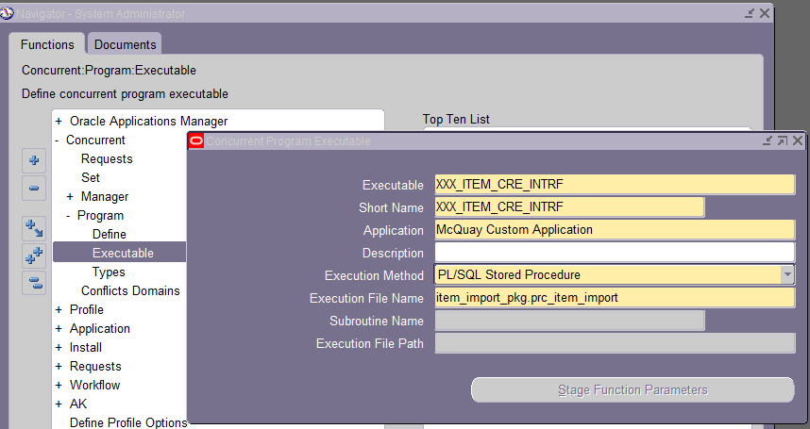

**➢ Create Concurrent Program for that executable.**

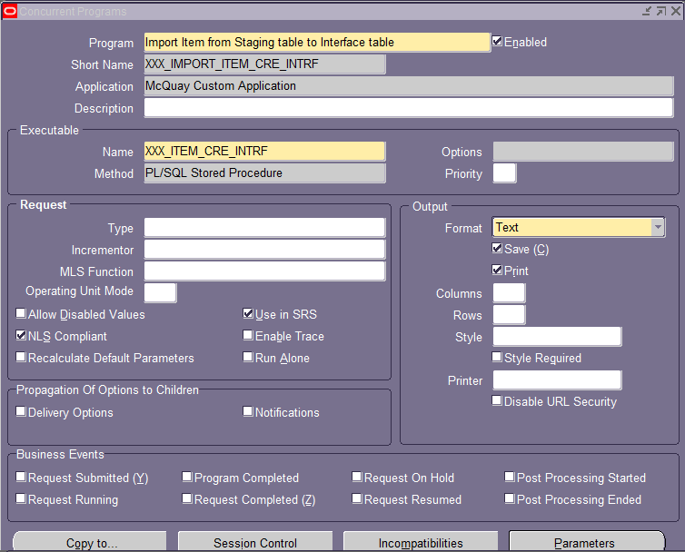

**➢ Request Group**

**Navigation→ System Administrator→ Security → Define**



**Navigation→ System Administrator→ Security → Request**

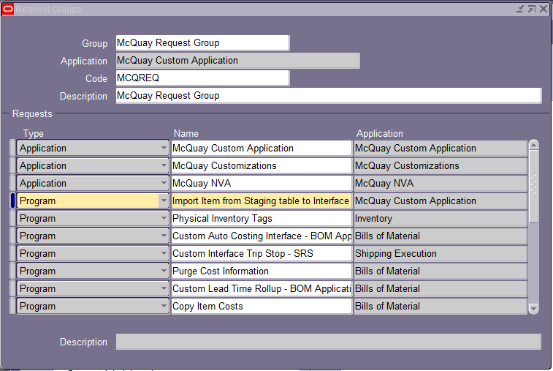

**Step 9:** Run the concurrent program

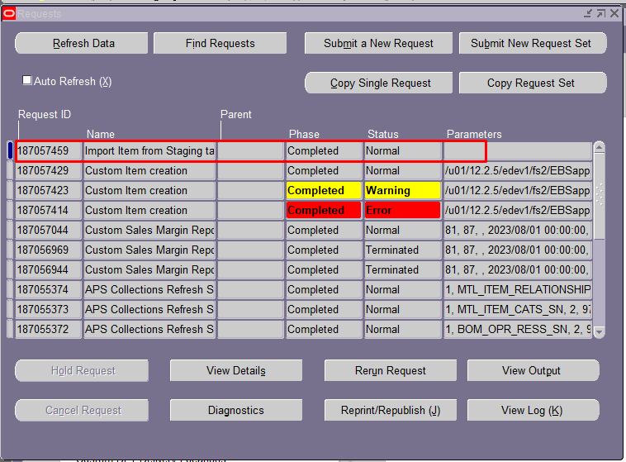

After completing the program, check the iterface table whether the records are inserted or not.

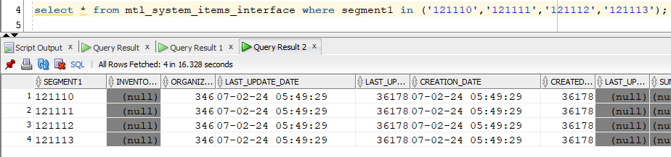

**Step 10:**

Now run the seeded concurrent program to insert the values from interface table to base table.

**Program Name:** Import Items.

